Adding Items to Azure Cosmos DB Using the .NET SDK

Summary:-
In this lab, you will use the Azure Cosmos DB .NET SDK to insert JSON documents into an existing Azure Cosmos DB container. You will update the console application, execute the program, and verify that the documents are successfully added to the Orders container.

Let's Start:-
After completing this lab, you will be able to:
- Connect to an Azure Cosmos DB account using the .NET SDK.
- Add JSON documents to an Azure Cosmos DB container.
- Execute a .NET console application to insert documents.
- Verify the inserted documents in the Azure Portal.

Lab Steps:-

Step 1 – Prepare the Azure Cosmos DB .NET Project
- Reference: This lab uses the .NET console application, Azure Cosmos DB account, database, and container created in the previous lab.
- For that create Azure Cosmos DB account by selecting Azure Cosmos DB for NoSQL from the recommended APIs.
- Configure:
Workload type: Learning, Region: EAST US/ EAST US 2, Capacity Mode: Provisioned Throughput
- Enable Apply Free Tier Discount. Click Next.
- Ensure Geo-Redundancy and Multi-region Writes is Disabled. Click Next.
- Select Enable access from all networks. Click on Review + Create to create.
- From the left pane, select Keys.
- Copy: URI and Primary Key
- Open Visual Studio Code. Create a new project folder.
- Press Ctrl + Shift + P to open the Command Palette.
- Select Show and Run Commands > .NET: New Project > Console App(Rename it as cosmosdb-app) > Default Directory > .slnx > Create Project.
- Open the integrated terminal. Run:
cd .\cosmosdb-app\
dotnet add package Microsoft.Azure.Cosmos
dotnet add package Newtonsoft.Json
- This step creates a .NET console application and installs the required packages to interact with Azure Cosmos DB.

Step 2 – Update the Program Code
- Open the cosmosdb-app project.
- Replace the following files with the provided files:
  - cosmosdb-app.csproj
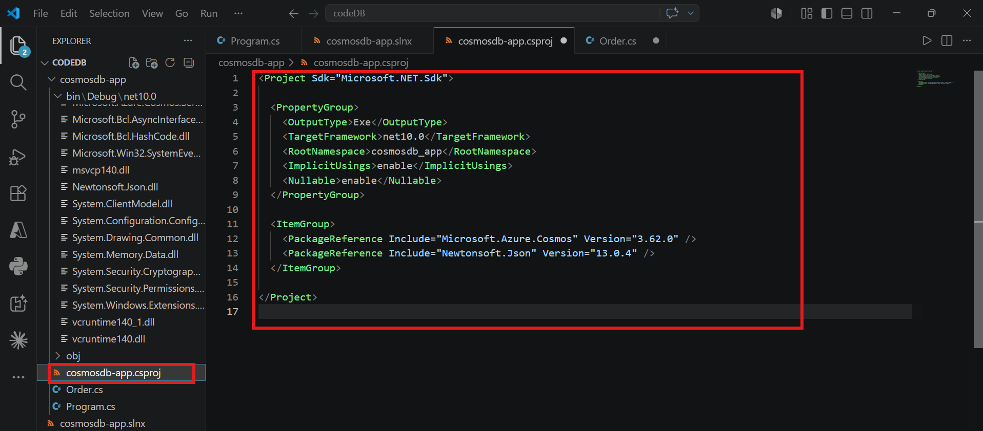
  - Order.cs
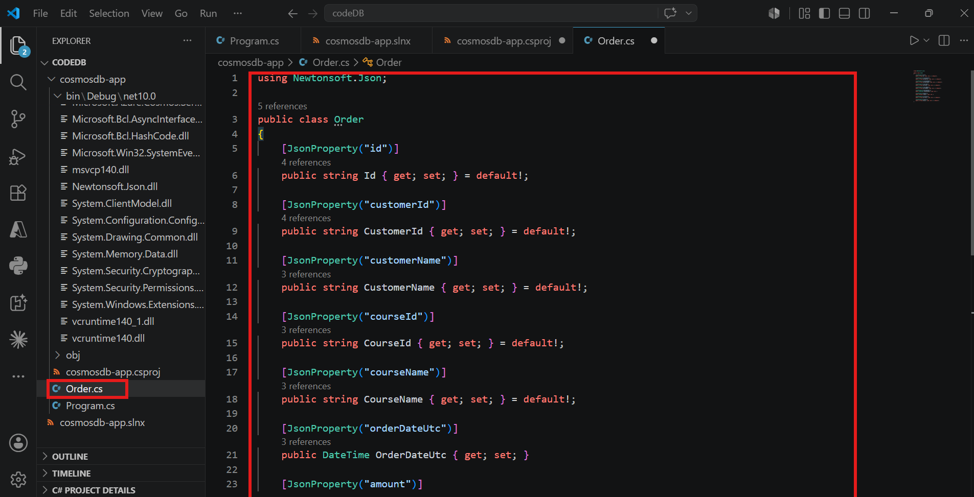
  - Program.cs (Replace Endpoint with URI and Key with Primary Key)
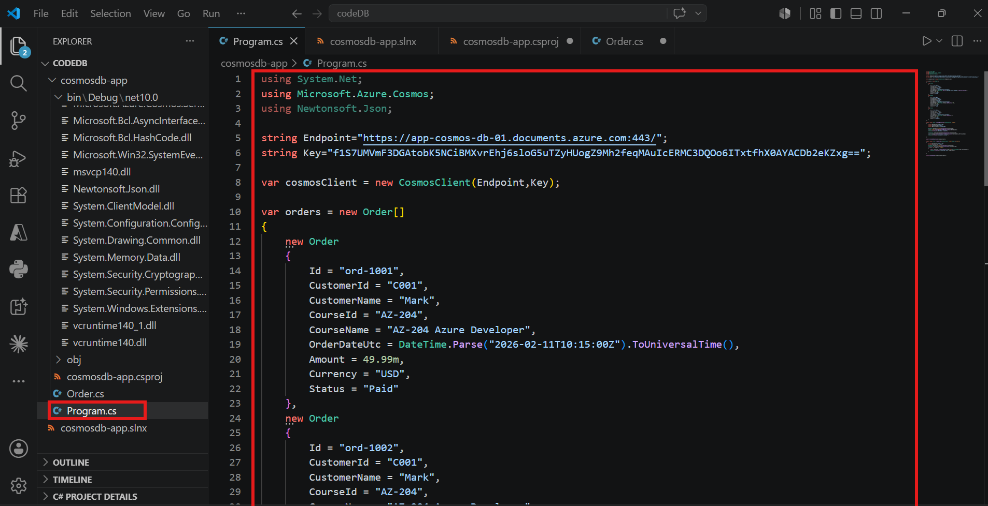
  - cosmosdb-app.slnx
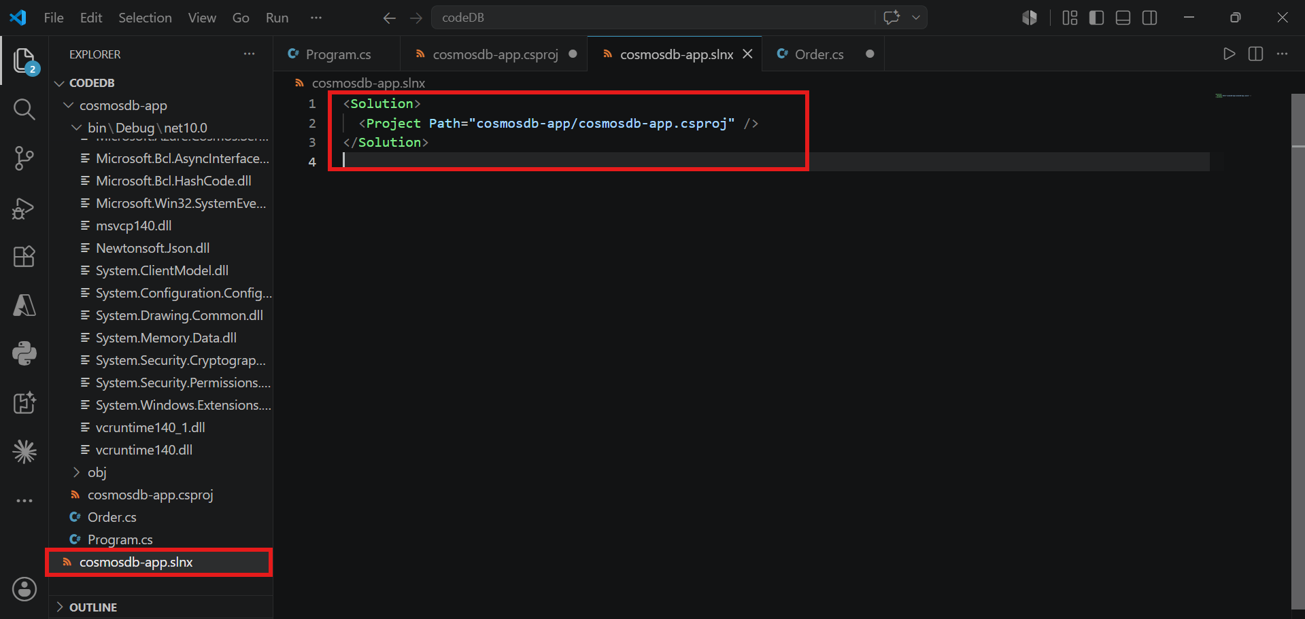
- Save all the files.
- This step configures the .NET application with the required project, model, and program files to interact with Azure Cosmos DB.

Step 3 – Run the Application
- Open the integrated terminal.
- Execute:
dotnet build
dotnet run
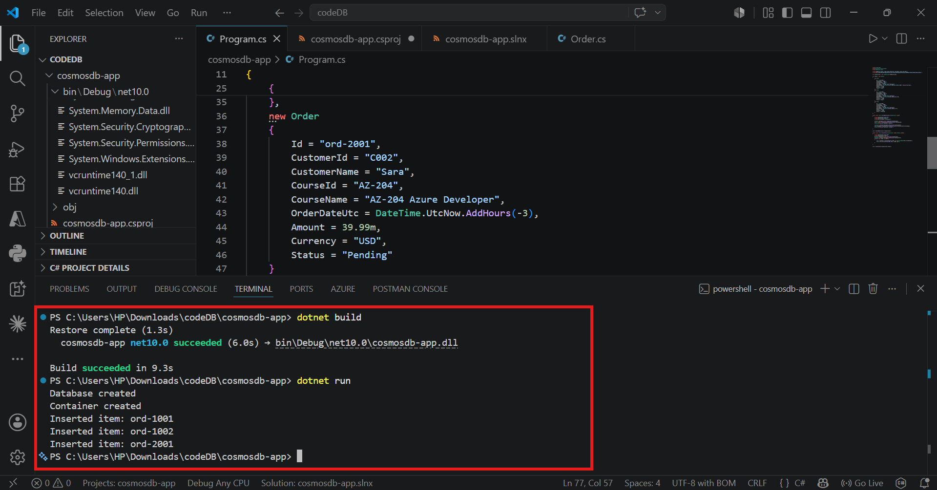
- Wait for the application to complete successfully.
- This step inserts the JSON documents into the Azure Cosmos DB container.

Step 4 – Verify the Inserted Documents
- Sign in to the Azure Portal.
- Open your Azure Cosmos DB account.
- Select Data Explorer.
- Expand the database and the Orders container.
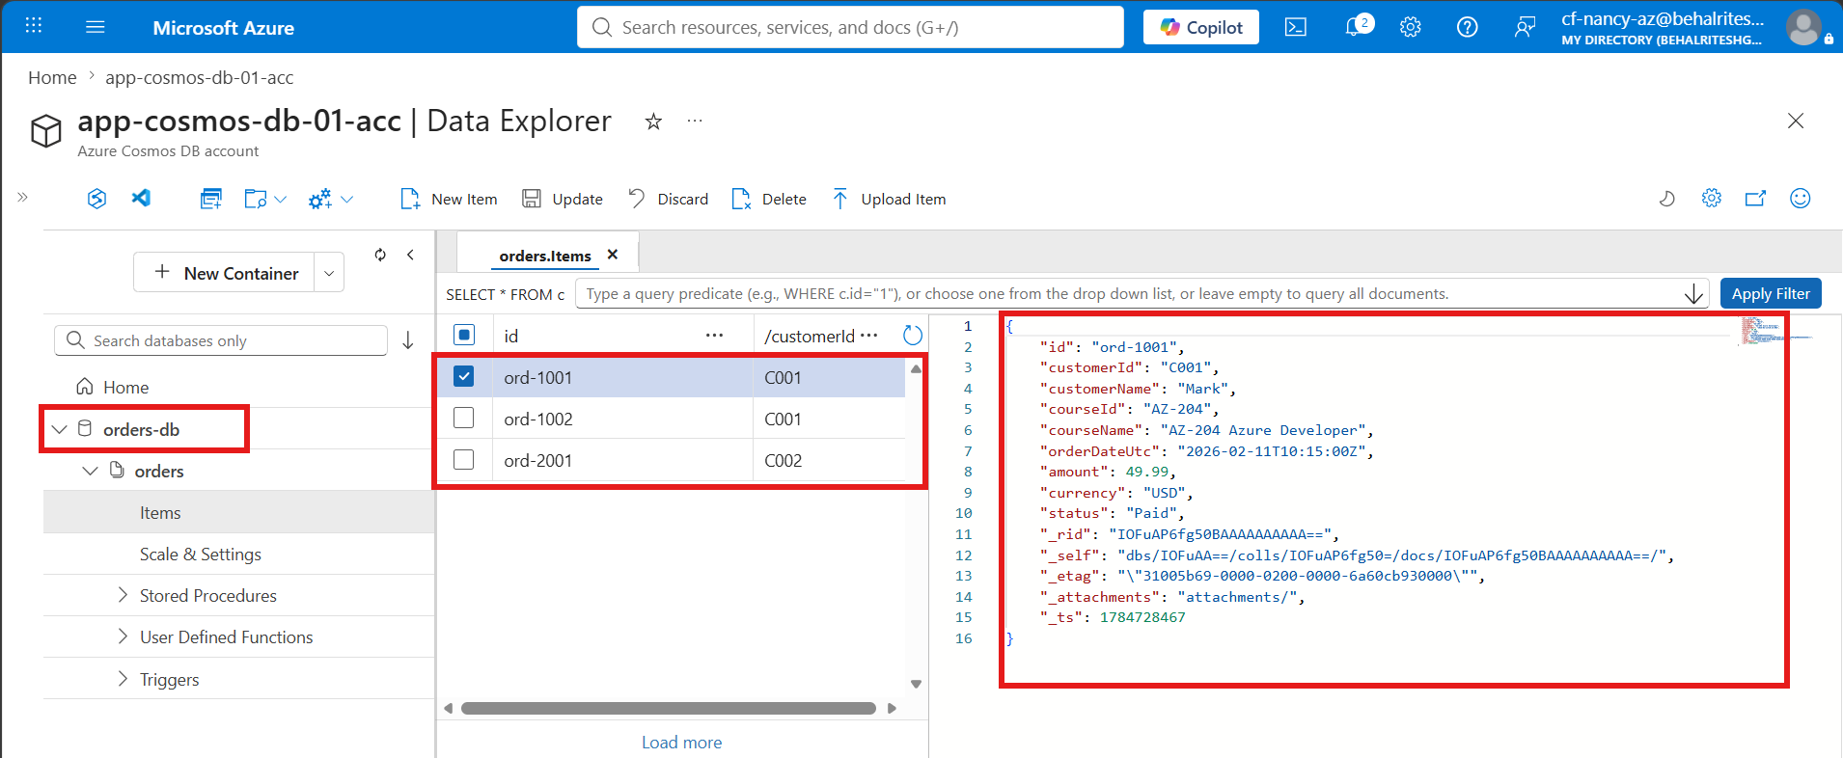
- Select Items.
- This step confirms that the documents were successfully inserted into the Azure Cosmos DB container.

Verification
Verify the following:
- The .NET application executes successfully.
- JSON documents are inserted without errors.
- The inserted documents are visible under the Items section.
- Each document contains the expected properties and values.
- The data is successfully stored in the Azure Cosmos DB container.

